FX -TRADING API USER GIUDE

# Book-Trade :

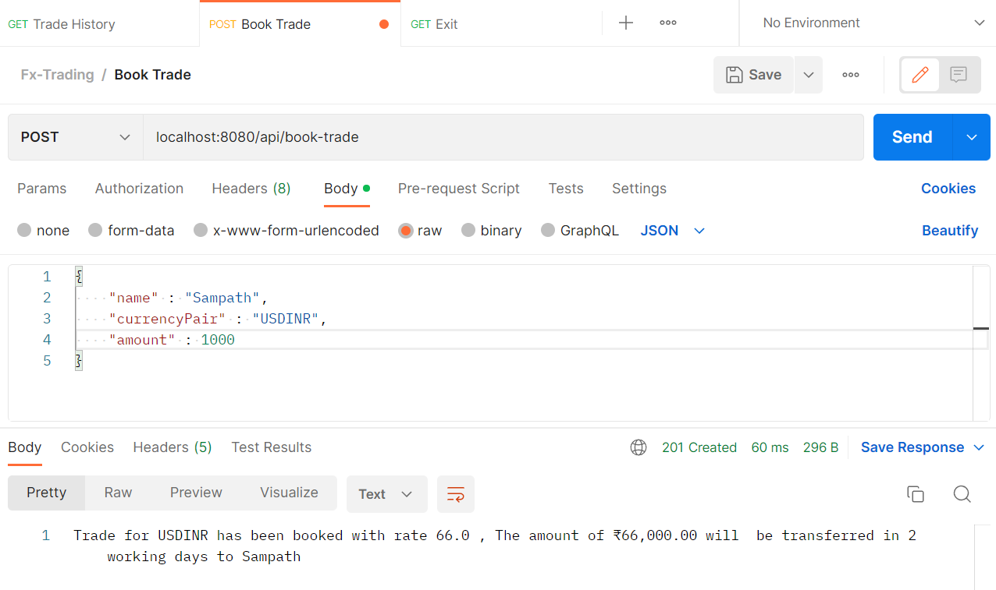

* Book-trade POST API will accept three JSON attributes “name, currency pair, amount”.
* It will return the booking confirmation message. So the user can confirm the last was booked.
* User Name should start with alphabets only.
* User Name can contain underscore, space, digits, length should be 3 to 24
* User name can’t be null or empty otherwise it will throw exception like “Invalid user name”
* Currency Pair should be “USDINR” currently USDINR transaction only allowed.
* Amount should be greater than 1, not a negative value otherwise it will throw exception.

# Trade-History :

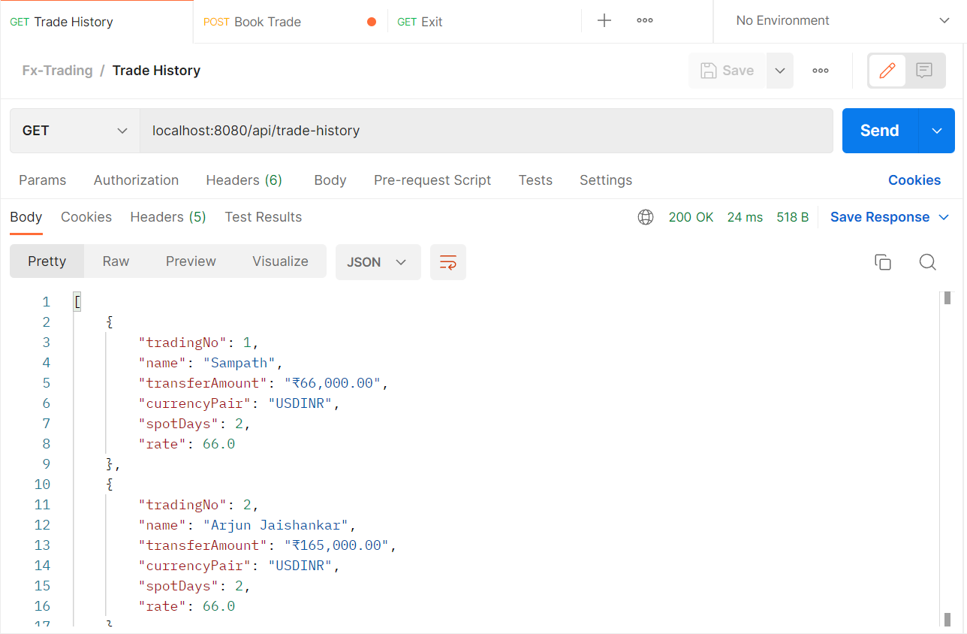

* Trade-history GET API will return the trading history.
* The JSON object will contain “trading no, name, transfer amount, currency pair, spot days, rate”
* If you haven’t done any trading still tries to access the API then it will throw exception like “Information : you haven’t done any trading.”

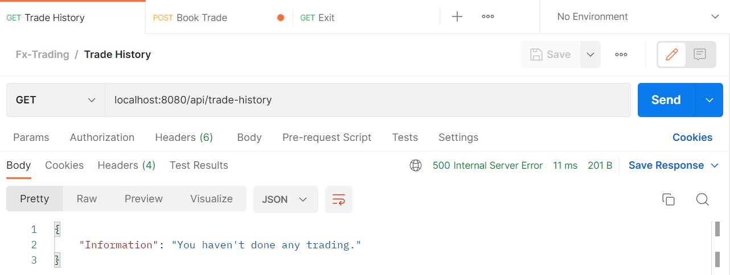

# Exit :

* Exit GET API will return string which contains “Bye - have a good day”.

